Santa Clara County Mother Friendly Employer Program

Lactation Accommodation Policy Template

Breastfeeding benefits mothers, babies, and employers. Not breastfeeding increases the risk of numerous health problems in both mothers and their children. Employers who support breastfeeding experience a variety of benefits including, lower healthcare costs, improved employee morale, increased productivity, and reduced absenteeism.

Having a lactation accommodation policy helps to support breastfeeding mothers within an organization. This template is designed to help employers develop a strong lactation accommodation policy that meets the requirements of the Santa Clara County Mother Friendly Employer Program. Employers may customize this template and/or create their own policy that meets the needs of their organization. As long as the policy meets or exceeds the minimum requirements of the program, an employer may be designated as a Mother Friendly Employer.

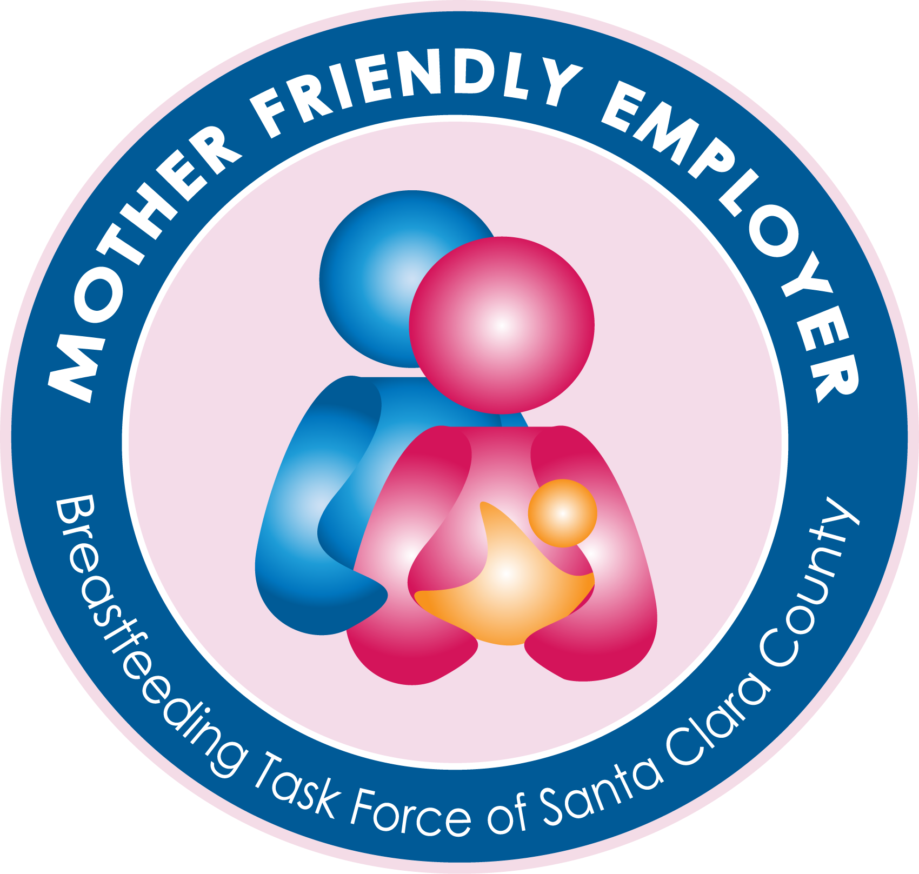

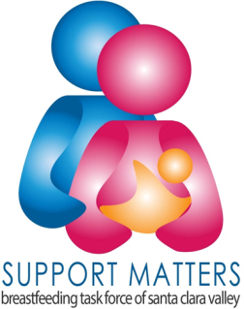
Funded by FIRST 5 of Santa Clara County

Updated 9.24.14

[Organization] Lactation Accommodation Policy

POLICY:
[Organization] recognizes that breast milk is the optimal food for growth and development of infants. It is the policy of [Organization] to provide a room or other private location for employees who wish to express breast milk or breastfeed at work. Lactation accommodations will be provided to employees for as long as they desire to express breast milk or nurse their infant. In addition, [Organization] will provide a reasonable amount of break time to accommodate employees desiring to express breast milk or nurse their infant.

Policy Goals:
- To establish guidelines to promote a work environment that supports breastfeeding at [Organization].

- Breaks
  - A reasonable amount of break time must be provided to employees who want to express breast milk or nurse their infant.
  - If possible, the break time should coincide with the employee’s paid break time. If not, the break time will not be paid.

Additional Suggestion:
  - With supervisory approval, the employee may use personal leave, vacation time, sick leave, comp time, or a flexed work schedule to cover any unpaid break time.

- Space
  - [Organization] will make a reasonable effort to provide employees with a room or other locations in which to express milk or nurse their infant. This space must not be a bathroom and should be private and in close proximity to the employee’s work area.
  - Ideally, the space will have a door that locks. If this is not possible, a room can be made private by placing a message on the door that the room is in use, drawing blinds or curtains, covering windows without curtains, or setting up a portable partition. The space should be clean and comfortable, equipped with an electrical outlet, and contain comfortable seating and a table or other flat surface to hold a breast pump. It should also be located near a sink with running water for hand washing and cleaning of equipment.
  - For non-traditional worksites, the department and supervisor will work with the employee to create a mutually acceptable solution. This may include a flexible schedule to allow the employee to return home for such activity, a temporary transfer to another facility, or other resolution.
- Storage
  - A hygienic and secure location will be available for employees to store expressed milk.

- Notification/Education
  - A copy of this policy will be disseminated to every incoming and current employee.
  - A breastfeeding education packet, including a copy of this policy and breastfeeding support after returning to work, will be provided to employees prior to their maternity leave.

Additional Suggestions:
  - Breastfeeding accommodation information will be included in employee orientation materials.
  - Supervisors will be trained on breastfeeding benefits, laws, guidelines, and policies.
  - Materials related to breastfeeding and lactation accommodation will be posted on the [Organization] website.
  - Information promoting the benefits of breastfeeding and lactation accommodation shall be displayed in break areas and be featured in [Organization] email communications at least once per year.

- Atmosphere of Acceptance
  - Breastfeeding should not constitute a source of discrimination in employment or in access to employment. It is prohibited under this policy to harass a breastfeeding employee or exercise any conduct that creates an intimidating, hostile or offensive working environment. Any incident of harassment of a breastfeeding employee will be addressed in accordance with [Organization’s] policies and procedures for discrimination and harassment.

